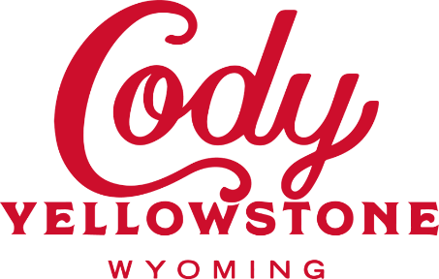

Park County Destination Development Community Program

These funds, made available through the Wyoming Office of Tourism, will be awarded for projects that focus on enhancing the tourism industry through new outdoor recreation infrastructure, enhanced experiences throughout Park County, and offerings bringing economic impact to our local communities. Various awards will be offered between $10,000 and $100,000. Pre-applications will be reviewed and scored by a Destination Development Committee. The dollars will be evaluated for enhancing the tourism economy and industry, economic impact, new infrastructure, budget and project costs, multiple funding sources, and community support.

**Applicant Background Information**

1. Applicant Name Click or tap here to enter text.
2. What organization or agency does the applicant represent? Click or tap here to enter text.
3. Will the proposed project include any contracted work?  Yes  No
4. Will the proposed project include any permanent infrastructure?  Yes  No
   1. If yes, please give a brief description:

Click or tap here to enter text.

1. Proposed Start Date: Click or tap here to enter text.
2. Proposed End Date: Click or tap here to enter text.
3. Check Classification of Project Applicant:

County

State

Municipal

Partnership

Private

Non-Profit

1. List any partners on the project.

Click or tap here to enter text.

1. Select All Management Agencies That Oversee the Land:

US Forest Service

Bureau of Land Management

Bureau of Reclamation

National Park Service

State Parks

Fish & Wildlife Service

State Lands

Bureau of Indian Affairs

Private

1. What is the economic impact of this project for Park County Click or tap here to enter text.
2. How does this enhance the
   1. Nonresident experience Click or tap here to enter text.
   2. Tourism economy and industry Click or tap here to enter text.
3. Generally, describe the proposed project:

Click or tap here to enter text.

1. Describe the statement of need for this project:

Click or tap here to enter text.

1. Describe any challenges or barriers that may exist in the completion of this project and how they will be addressed:

Click or tap here to enter text.

1. Describe any maintenance that would be required for the proposed project. Include the entities that would be responsible for the ongoing maintenance of the project.

Click or tap here to enter text.

1. Please provide a site map of the proposed project area.
2. What level of environmental clearance is needed on the land of the proposed project? Has this been completed? Provide documentation of what has been completed.

Click or tap here to enter text.

1. What level of cultural clearance is needed on the land of the proposed project? Has this been completed? Provide documentation of what has been completed.

Click or tap here to enter text.

1. What public engagement or collaborative processes have been utilized to plan for this project?

Click or tap here to enter text.

* 1. Is there broad community consensus for the proposed project?  Yes  No
  2. Please provide supporting documents for this.

*I hereby certify that the application form and all attachments are correct and truthful to the best of my knowledge. I also certify that I understand the Park County Destination Development Grant Program, selection process and fully accept that all decisions are final.*

**Name of Authorized Contact Person** Click or tap here to enter text.

**Title** Click or tap here to enter text.

**Date** Click or tap here to enter text.

**Signature of Authorized Contact Person** _____________________________

**For any questions about the program, please contact Ryan Hauck at   
307.587.8589 or ryan.hauck@codyyellowstone.org**

**Please send this completed application to ryan.hauck@codyyellowstone.org or by mail to 1306 Sheridan Ave, Cody, WY 82414. All applications must be submitted by no later than April 23, 2025 at 5pm.**

**Important Dates**

**Pre-application opens: March 26, 2025  
Pre-application closes: April 23, 2025  
Application approved or denied: May 16, 2025  
In person presentations and final approval: June 12, 2025  
Dollars awarded: Within 30 days of the application deadline  
Project must near completion: May 30, 2026  
Final Report Due: June 11, 2026**